What is a Virtual Assistant?

A Virtual Assistant (VA) provides administrative support and specialised services to businesses, entrepreneurs, executives, managers and other busy people. They are highly skilled independent contractors who make use of the advances in modern technology to complete assignments via the Internet, email, floppy or CD. Traditional methods such as regular mail and overnight courier are also used.
Virtual assistants are available whenever you need them but, unlike a temporary employee, guarantee you the same great service from the same dedicated people every time without the problems associated with employing staff. The majority of virtual assistants have many years’ experience as senior secretaries or personal assistants and who choose, for a variety of reasons, to operate as a virtual assistant, virtual PA or virtual secretary.

Benefits of Using a VA?

- VAs offer flexibility – they are available outside of normal hours, have no minimum hour commitment and are only paid for the hours they work.
- VAs have a vested interest in the success of your business, so client confidentiality is paramount and they will treat your business as their own.
- VAs allow you to use the same highly skilled, professional every time you outsource work.
- You get more time to do what you do best, while leaving the admin to someone else.
- Your work will be completed to perfection and delivered on time – or ahead of time.
- No recruitment or agency fees incurred.
- Your VA will work closely with you to achieve seamless perfection of your projects – no one will ever know it wasn’t completed in-house! That goes for call answering too!
- No HR headaches like tax, national insurance or employee benefits.
- Employees and temps are paid by you for coffee breaks, toilet visits and time taken for personal calls and issues.
- VAs work from their own offices so you won’t have to organise workspace or equipment for them.
- VAs come in all different guises – there will be one out there that suits you and your business perfectly!
What is the Society of Virtual Assistants?
The Society of Virtual Assistants was formed in 2005 to:
- Raise the general awareness of virtual assistants within the UK business community.
- Provide a resource for clients looking for virtual assistants.
- Encourage virtual assistants to share their experiences and enable us all to grow.
- Help provide some balance in the information available for UK based VAs.
- Create and maintain universal standards that all VAs adhere to.

Having started as a Scottish resource, the organisation soon grew to involve VAs from all over the UK. It is the only organisation for virtual assistants in the UK which provides free membership, a discussion forum and insists on minimum standards for its members.

As we are not funded through subscriptions our VAs are regulated closely and we will remove any VA who has more than two complaints brought against them. If you have a complaint against a VA, we want to know, please email us on:
Info@SocietyOfVirtualAssistants.co.uk

If you would like further information about SVA or you are considering working with a VA and would like some help please either visit the website:
www.SocietyOfVirtualAssistants.co.uk
or email:
info@SocietyOfVirtualAssistants.co.uk
Why use a VA approved by the Society Of Virtual Assistants?

By using an approved VA you can be assured of a professional and speedy response because all our assistants promise to:

- Be sufficiently competent in their listed skills to carry out the work you request
- Respond to emails sent during
business hours within 24 hours.
- Respond to phone calls during
business hours within 24 hours.
- Have a professional quality website
and email systems
- Agree to be removed in the event of
breaking any of these rules or having
more than two complaints levied
against them by clients.

All approved VAs will display this logo on their website:



www.SocietyOfVirtualAssistants.co.uk
Why not give me a call to see how a Virtual Assistant could help your business?



designed by
www.office-ally.co.uk
© November 2006

What is a Virtual Assistant?

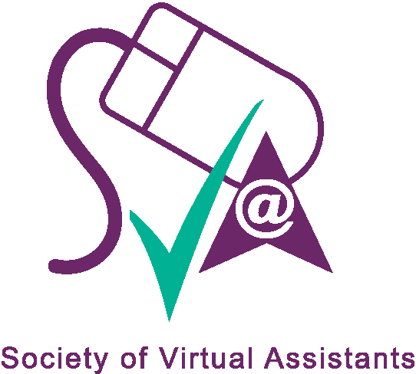

www.SocietyOfVirtualAssistants.co.uk

