LinkedIn Cheatsheet...
Contents
How LinkedIn Works 2
Creating the Company Page 3
Adding employees to the company 3
Adding testimonials from your clients 3
Connecting with other people 3
Organising contacts 4
Discussion Group Marketing 4
Create own discussion group 5
Answering Questions on LinkedIn 6
Updates 6
Impact on your own website 6
Incoming Traffic 7
Ideas for topics 7
Paid Version 8
Action Points 9

How LinkedIn Works
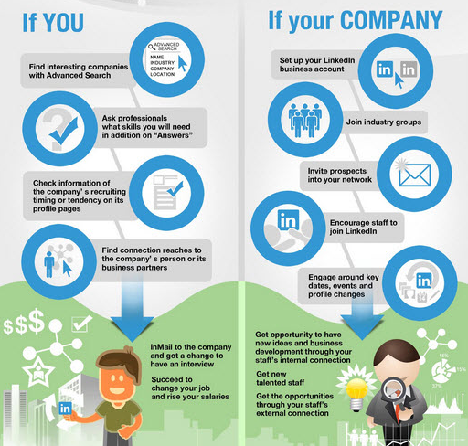
Essentially it’s about connecting you to other people through your contacts:
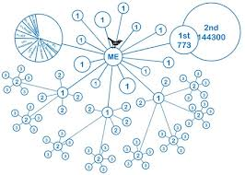
So our aim is to connect you to as many people as possible, so they can share your information that you send out with as many people as possible. LinkedIn likes to connect people rather than companies, so whilst you can do status updates for the company and have people follow your updates, there will be a fair amount of personal interaction.

Creating the Company Page
- Add a picture to your profile – it should be PNG, JPEG, or GIF format, max size 2 MB. Image must be 646 x 220 pixels or larger.
- Create square logo of 50x50 pixels for status updates.
- Created a company profile including relevant keywords.
- Create “products/services” which can be listed under a variety of different categories in order to capture people who are looking for those services. This is where your clients will click in order to recommend you and rate your service.
- Location: LinkedIn lets you list up to five locations and many members will search via postcode
- Every week you need to check who is following the company and connect with them/check them out. To do this, click on COMPANIES/YOUR COMPANY and top right there is a “# followers” – click this link and check you are connected with anyone new.

Adding employees to the company
- Move your cursor over Profile at the top of your home page and click Edit Profile.
- Click Edit next to your current position.
- Click Change Company and type the full company name.
- Important: This step is crucial. Click the correct company name in the dropdown list.
- Click Update.
Make sure that everyone has included all previous jobs (this makes it easier to connect with their former colleagues and connections of their former colleagues!).
Connect with everyone in their address books and previous jobs to increase their network.
Make sure they list their expertise in their profile – these act as keywords in order to make searching for specific skill sets easier.

Adding testimonials from your clients
Direct clients to the Company Page and the Products and Services tab.
They can add their recommendations and testimonials here.

Connecting with other people
You don’t want to have lots of outstanding contact requests – LinkedIn locks accounts with too many. To check, click on your inbox sent invites: http://www.linkedin.com/inbox/invitations/sent
You can delete any which are outstanding. As a general rule, I’d try not to add more than 25 contacts in any one sitting, and to keep to this level of outstanding invites. If you don’t get a response, they obviously don’t use LinkedIn or don’t want to connect, so delete them from your invites and use it for someone who does want to connect!

You can also get introduced by someone in your network... E.g. Let’s say you want to connect with Joe Bloggs, look to see if there are any of your friends who are already connected to him and they can introduce you.
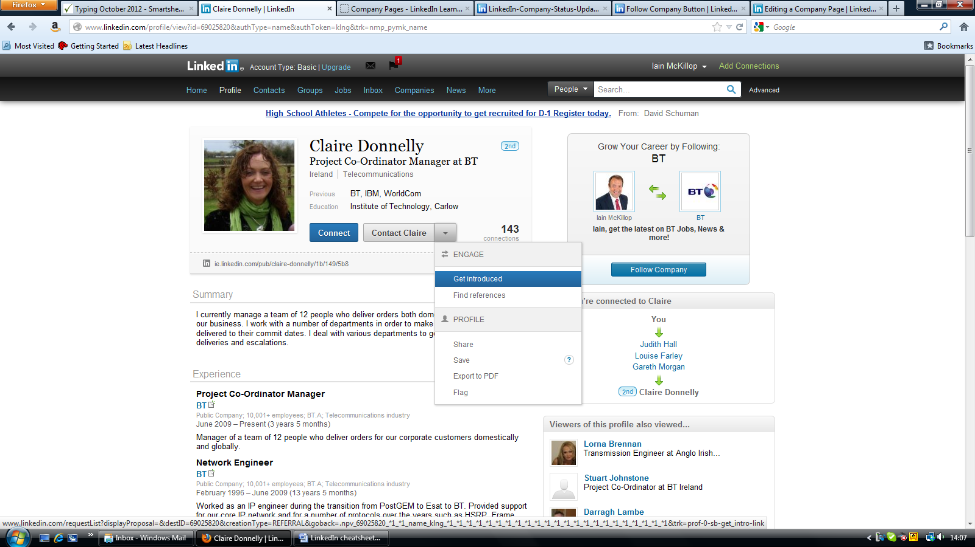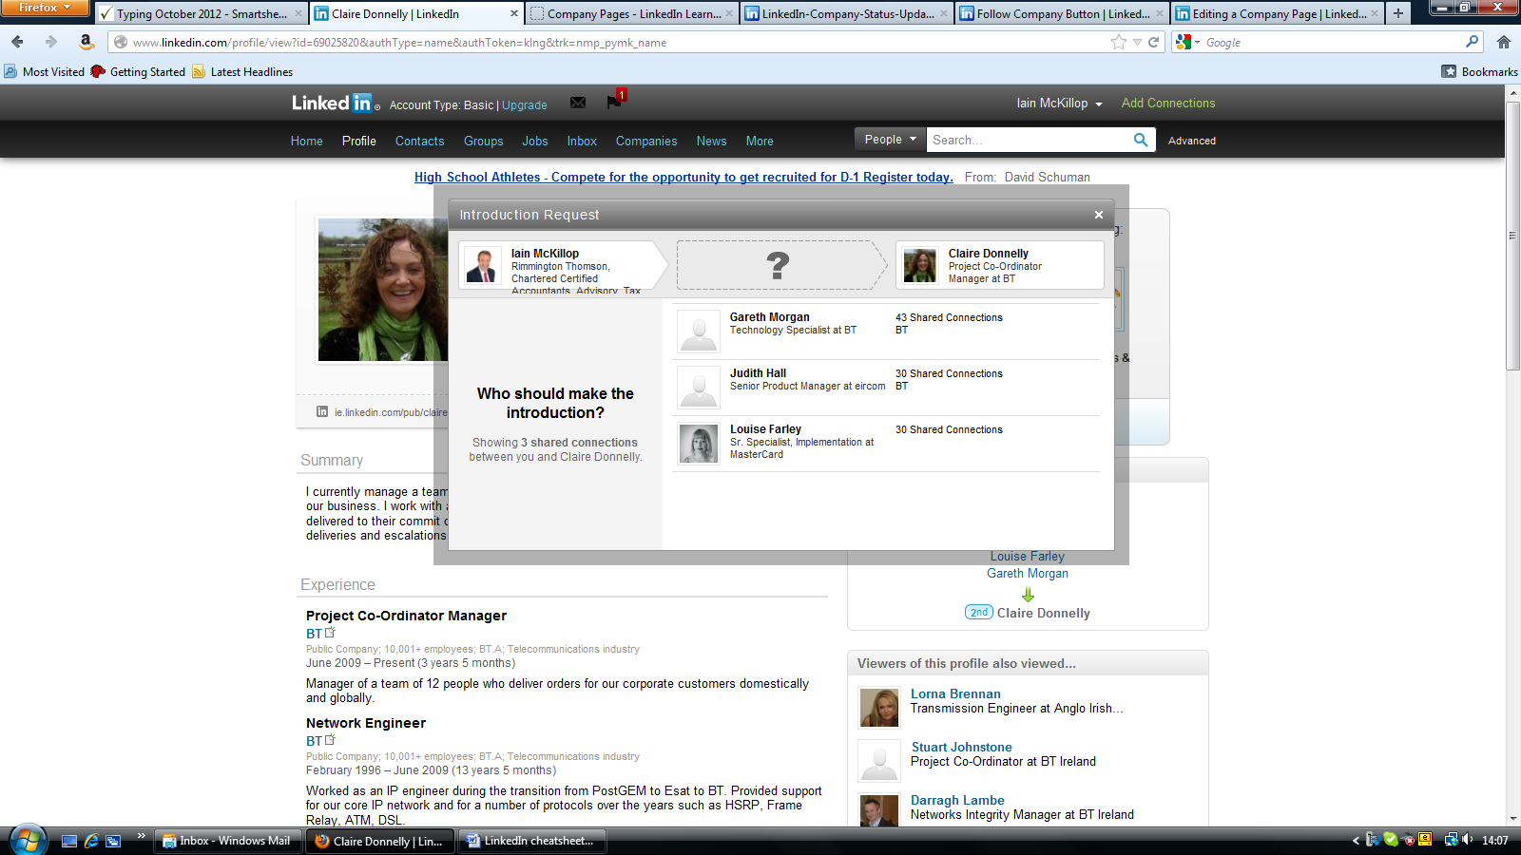
You can pick will introduce you and include a personalised message.
Most people don’t mind being asked to connect unless it is clearly spamming them. After all, they are on here to connect with people too!
Sending a personalised message rather than the generic LinkedIn message can really work – tell them why you want to connect with them, explain what your interest is in their company and include your contact details.

Organising contacts
When you have all your contacts in your address book, it’s best to organise them into groups of people using the TAGS feature. You can have as many tags as you like on one person e.g. I might be listed under “suppliers” “VA” “tech people” etc – you make up the tag names, they are not visible to anyone else.
You can email each group via LinkedIn as long as the groups are less than 50 people – so there’s a good argument for having separate groups within each tag (so you might have “client group 1” “client group 2” etc.) for ease of emailing.
To do this click on the CONTACTS tab, select “untagged” and tick the people you want to put into a group. On the right hand column, there will be an option to “EDIT TAGS”. Press save and you have your new group of people.

Discussion Group Marketing
Connecting with groups on LinkedIn is very important – because they are subject (and sometimes location) specific, you’ll get a lot more useful information and contacts from them. Firstly it allows you to demonstrate expertise and secondly being connected to a contact via a group makes it easier to connect with them.
Depending on their message settings, group members will get a digest of the activity in the group so if you’ve contributed to a discussion or started one, your name gets flashed in front of them on an email:
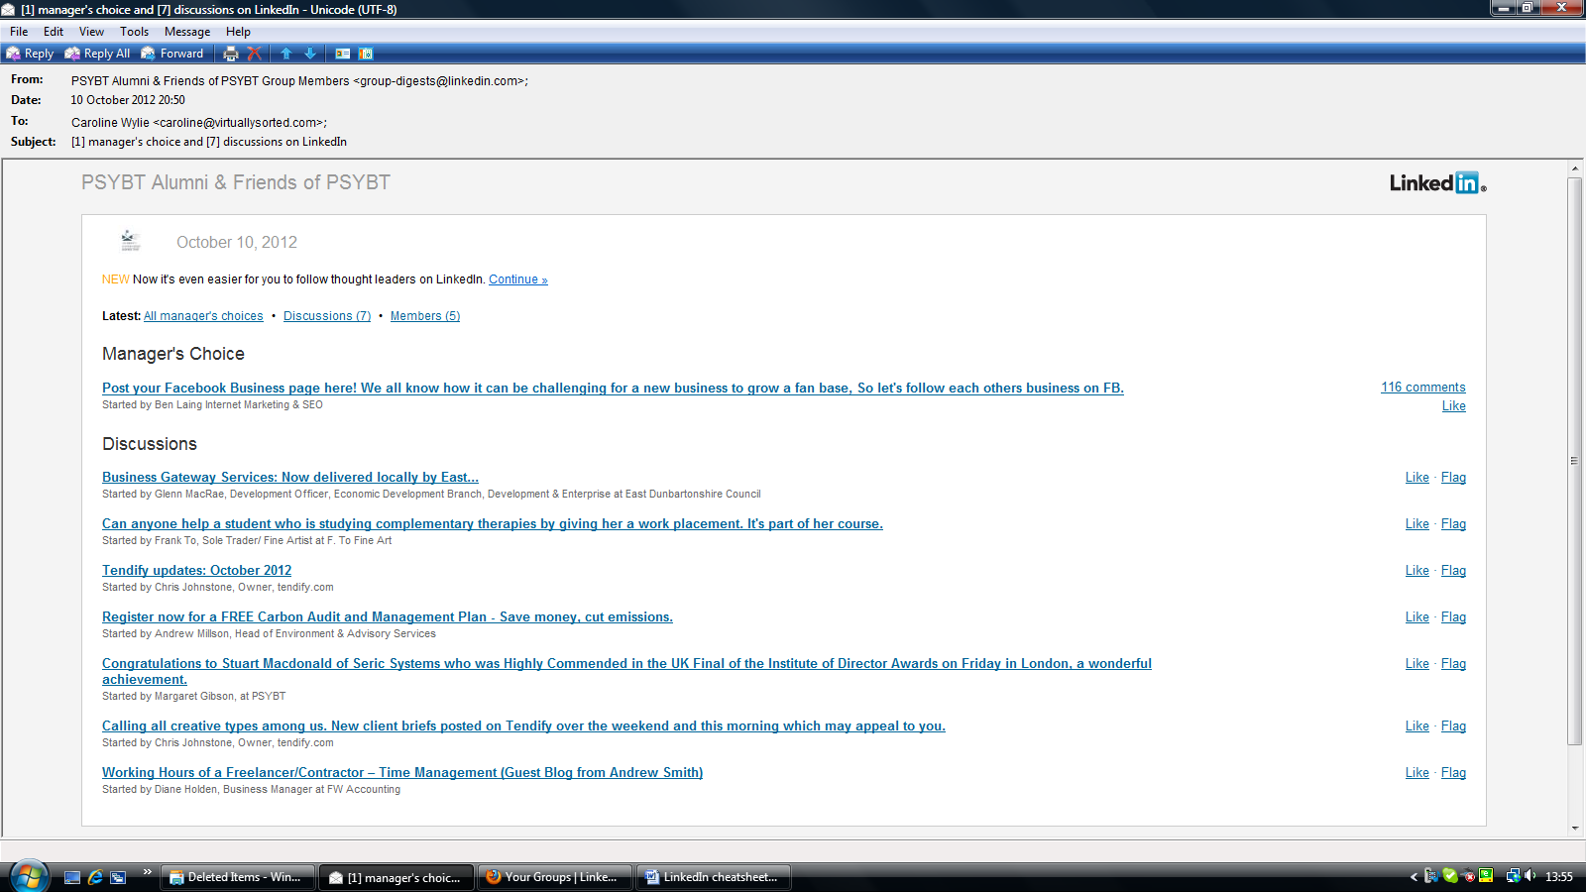
Typical email update from a discussion group
Connecting with people in groups also gets easier as you can say you know them through the Group on LinkedIn’s connect page:
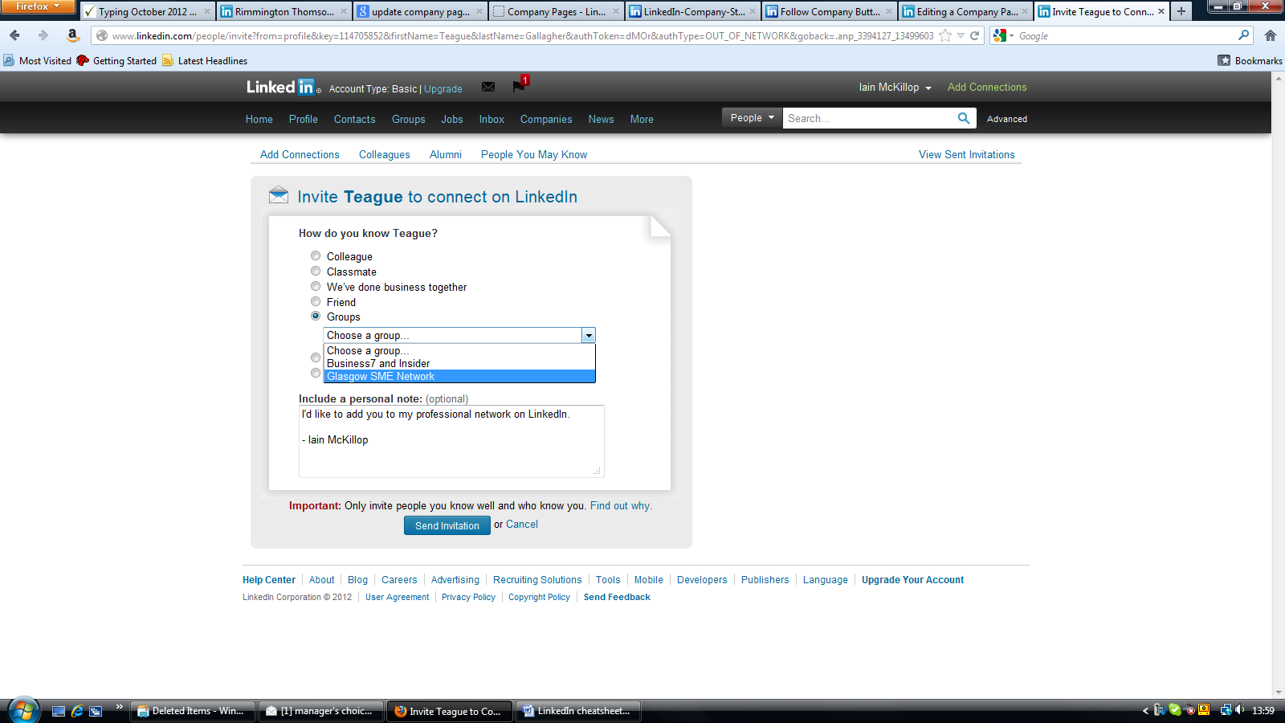
We suggest looking for one new group per week with people in your target market and posting or commenting on each group you are a member of once per week.

Create own discussion group
I’d suggest waiting until you’ve got your head round the way the groups work before creating one of your own... However creating a group for your target market is one of the best ways of contacting people who might not necessarily contact you otherwise.

Answering Questions on LinkedIn
The Q&A section http://www.linkedin.com/answers?trk=hb_tab_ayn may be useful in demonstrating your knowledge. However it’s not particularly focused and the Question may be posed by anyone worldwide or answered by anyone worldwide, so it’s not very specific.
Suggest doing a search on questions once per week under the “ADVANCED ANSWERS SEARCH” and refining it by area or keyword.
Sort this by “DEGREES AWAY FROM YOU” and hopefully it’ll minimise the amount of time you spend answering questions for international clients who wouldn’t be your potential market.

Updates
This is the social media bit of LinkedIn where people share what they are doing. You see these when you log in on your front page:
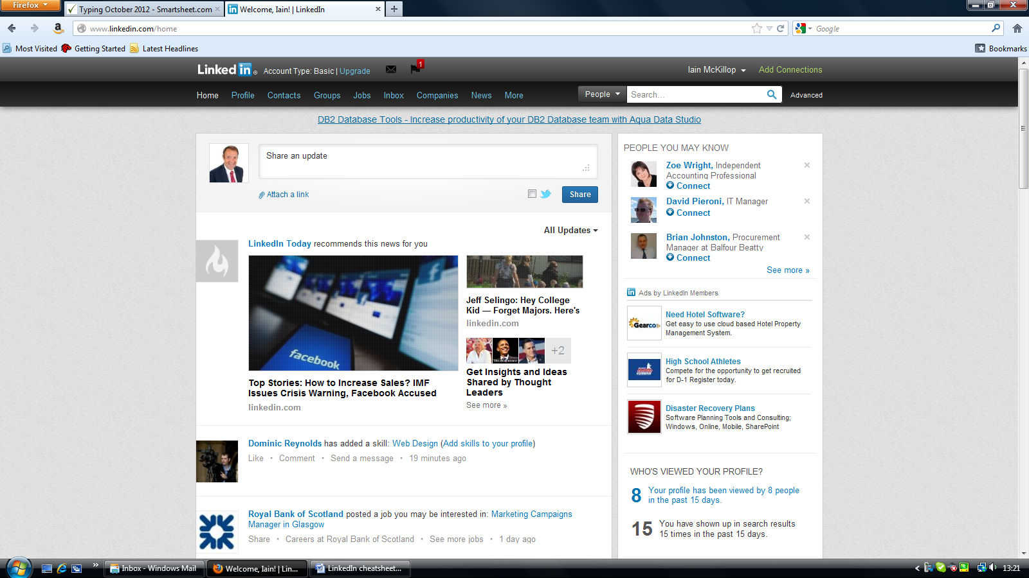
You can either post as a person. You don’t need to physically be sitting there making the updates at 10am Tuesday, 4:33pm Wednesday etc – you can schedule these using a tool like Tweetdeck or Hootsuite. You can also synch your RSS website feed to update LinkedIn – you’ll need your feed address to set this up!

Impact on your own website
Ideally you’ll have loads of info to post on updates, answers and the discussion groups. However, whilst LinkedIn is a good standalone platform for marketing, it also is an opportunity to create backlinks to your own website and increase your SEO.
Google likes to see lots of visitors going to your site, so if you can put interesting info on your blog and then send visitors from LinkedIn to view it, Google will rank the website higher in the search engine as a result. Google also likes to see external sites referencing your website as it confirms that people respect what you are saying and that your site is of interest to people – there was a particular focus on backlinks in the latest Google Penguin update. LinkedIn counts as an external site, so if you can link back to your site from there, it’s a good thing.

Incoming Traffic
To create incoming traffic to your LinkedIn profiles, please ensure that your company page and personal profile links are included on all outgoing emails, in any forum signatures, the new website etc.

Ideas for topics
Couple of ideas on subjects for updates, answers and discussion groups:
- News stories – post the link to a news story and a brief description of what the impact would be.
- New staff – Always nice to welcome new staff and link to their personal profile.
- New clients – With their permission of course! It creates a good bit of PR for them and for you.
- Top 10 Most Common Mistakes – List of the most common mistakes people make with their admin. You could even make this into a checklist or quiz?
- Polls – LinkedIn allows you to run polls on the discussion groups – you could do one on “how do you rate your VA?” “What’s the number one thing that bugs you about your admin assistant?” etc.
- Tax dates – Post reminders regarding tax dates and deadlines.
- Office stuff – How do you work differently from other VAs? Anecdotes about the types of clients who use you, what they like about the service, how much money it saves them, etc. – you can keep these vague for client confidentiality.
- Pictures/infograms – Pictures of staff, pictures of how your service works in flowchart format, pictures of happy clients etc.
- Statistics – What’s the average aged debtor days on SME accounts? How many people hang up when they get an answerphone?

Paid Version
This is the paid version of LinkedIn – basically it allows you to connect with people who are not in your network already and it also allows you to see who has been checking out your profile and then contact them directly.
 | Personal Plus | Business | Business Plus | Executive
Contact anyone directly with InMail |  | 3 | 10 | 25
See more profiles when you search | 100 | 300 | 500 | 700
Zero in on profiles with Premium Search Filters |  | Premium | Premium | Premium + Talent
See expanded profiles of everyone on LinkedIn |  | Yes | Yes | Yes
Who's Viewed My Profile: Get the full list | Yes | Yes | Yes | Yes
Save important profiles and notes using Profile Organizer | 5 folders | 5 folders | 25 folders | 50 folders
Automate your search with Saved Search Alerts | 3 per week | 5 per week | 7 per week | 10 per day
Get introduced to the companies you're targeting | 10 outstanding | 15 outstanding | 25 outstanding | 35 outstanding
See names of your 3rd degree and Group connections | First Name | First Name | First Name | Full Name Visibility
Get the real story on anyone with Reference Search | Yes | Yes | Yes | Yes
Let anyone message you for free with OpenLink | Yes | Yes | Yes | Yes
Get priority customer service | Yes | Yes | Yes | Yes
Price: | £6.95/month | £16.95/month | £32.95/month | £64.95/month

Action Points
This checklist will show you where you are now and where you are in 1 month’s time:
LinkedIn | Now: | Where I want to be: | Results:
Do you have a business page & a personal profile? | y/n
Have you fully listed all your jobs and added all your contacts? | y/n
How many connections do you have?
Do you have your connections divided into lists? (e.g. Friends, customers, people interested in Product X etc.)
What groups are you a member of?
Time spent each week?
How many leads are you getting per month from LinkedIn?
How many new clients do you get per month from LinkedIn?

What I’ll do to improve my LinkedIn page:
Action: | Frequency: | Actioned By:

